**(LAB PROGRAM – 8)**

**Name: Anuj Solanki**

**Registered No: 20218411**

**Ques:** Create a window, having three labels. The first label displays “Christ University” in Green Color, Second Label displays .“School of Sciences” in Blue Color and the third box displays “BCA-5th SEM” in Red Color.

Change the font, Font-Size, Alignments, background color and foreground colors of these labels.

Program:

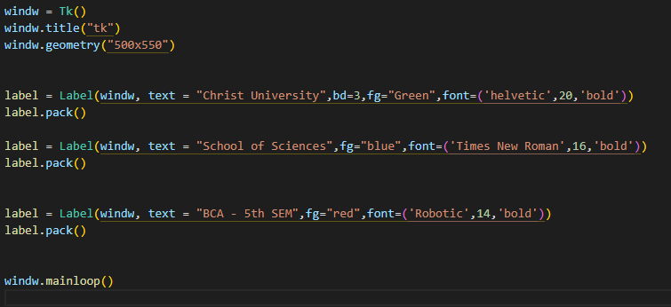

OUTPUT:

